Port state control
2017 annual Report

Taiwan, Republic of China

Published on June 2018

Contents

PSC inspect record during 2003-2016 12
Inspect highlight in 2017 15
2017 PSC Performance 16
Inspection highlight in 2018 24
Target of inspection distribute to maritime affairs centers as quarters of year. 26
PSCO training and recruit project in 2018 29
Conclusion 34
Appendix 1-Flow chart of PSC operation 35
Appendix 2-Form-A1 37
Appendix 3-Form-B1 38
Appendix 4- (Notificatio of release of ship) 39
Appendix 5- (Notification of detention of ship) 40
Appendix 6-Report of deficiency 41
Appendix 7(Report of action taken to the notifying authority) 42
Appendix 8-e-mail and address information for Flag states of ship 43
Appendix 9-Representative office in Taiwan 45

Figure list

Fig 1: Organization Chart of PSC 9
Fig 2 Inspection, deficiency and detention amount by ship age. 11
Fig 3 Inspection, deficiency and detention rate by ship age 12
Fig 4 PSC inspection amount and rate 12
Fig 5 PSC inspection deficiency amount and rate 13
Fig 6 PSC inspection detention amount and rate. 14
Fig. 7 statistics data by season 16
Fig.8:PSC inspection amount by ship type 18
Fig.9:PSC inspection amount by flag state 19
Fig.10:PSC inspection, deficiency and detention amount 20
Fig.11:PSC inspection, deficiency and detention rate 21
Fig.12: deficiency and detention statistics on Maritime affairs centers 22
Fig.13: deficiency and detention rate on Maritime affairs centers 23
Fig 14:Number of target & Inspected by Season during 2017-2018 27
Fig 15:Number of target &Inspected during by Maritime affairs centers 2017-2018 27

Table list

Table 1:PSC activities and performance 11
Table 2: Statistics data by season 16
Table.3 Major categories of deficiencies 2017 17
Table 4:PSC inspection amount by ship type 18
Table 5:PSC inspection amount by flag state 19
Table 6:General categories on port state control inspection by age of vessel 20
Table 7:Sum of inspection on Maritime affairs centers 22
Table 8:PSC inspection amount in 2017 and 2018 26
Table 9:PSC inspection amount between 2017 and 2018 by maritime affairs center 26
Table 10: Time window of PSC inspection. 31

Preamble:
- According to the order by President of the Republic of China (90) (華總一義字)hua tzung yi yi tz No.9000224660 Amendment to Article50 November 21, 2001 that〝The matters not covered by this Law relate to international affairs, MOTC may reference to international conventions or agreements and attachment of rules, methods, standards, recommendations or procedures for implement〞,Port Authority (Harbor Bureau) announced that commercial port safety and management items involve international affairs, competent authorities shall refer to Procedure for international conventions, agreements, rules, Port State Control and TOKTO MOU implement examination towards the entrance and departure of foreign merchant ships since 1st January 2003.
- PSCO perform basis on the Law of domestic:
  - The Commercial Port Law: Amendment to whole articles promulgated on December 28, 2011-Relevant Articles as follow:
    - Article 58〝The Procedures for Port State Control and its regulations announced by the commercial port authority according to the International Maritime Organization or other relevant authorities, should implement examination of ship certificate, security , equipment , crew quotas and other matters towards the entrance and departure of foreign merchant ships.〞
    - Article 59〝When the commercial port authority executes foreign merchant ship control examination, they should hand it to the master to sign after information have been recorded in the inspection record. If there are any violations, the commercial port authority has to be improved in a limited time.
After foreign merchant ships have made improvements according to the preceding paragraph, they should request the commercial port authority for reexamination, and pay for the reexamination fees as well. The amounts should be stipulated by the commercial port authority, and check and ratified by competent authority.〞.
    - Article 60〝When foreign merchant ships seriously violate control examination regulations, influence ship navigation safety of ship personnel, and can seriously threaten marine environment, the commercial port authority have to retain ships till improvements are completed, in order for them to be approved to navigate.
Where foreign merchant ships violate control examination regulation, our country has no repairing equipment technology, and no accessory material to provide to change or retain illegal ships. Those that will influence port safety or public interests, have to produce entry level verification proof, and receive approval from commercial port authority to be able to navigate.〞
    - Article 75〝When commercial port safety and management items involve international affairs, competent authorities shall refer to international conventions, agreements, and rules, methods, standards, suggestions of its supplementary rules.〞.
  - The Law Of Ships: The effective date of the amendment of Paragraph 1, Article 73 of this Law, amended on December 8th, 2010, regarding the affairs administered by the shipping administration authority, shall be determined by the Executive Yuan.
Article 101〝For other rules and regulations on ship technology and management, the competent authority may refer to the standards, recommendations, measures or procedures set down in the relevant international conventions or agreements and their annexes, and adopt them for promulgation and enforcement.〞
.
- In accordance with the provisions of the applicable Article 58、59、60 of The Commercial Port Law , Maritime and Port Bureau(MPB) may conduct inspections by PSCOs of foreign ships in commercial ports to verify that the condition of the ship and its equipment comply with the international regulations and that the ship is manned and operated in compliance with these rules. If there are any violations, the Maritime and Port Bureau may ask master of ship improved in a limited time. After rectified the deficiencies, Master of ship should request the Maritime and Port Bureau for re-examination, and pay for the re-examination fees as well. When foreign merchant ships seriously violate control examination regulations, influence ship navigation safety of ship personnel, and can seriously threaten marine environment, The Maritime and Port Bureau have to detain ships till improvements are completed in order for them to be approved to navigate.
The purpose of control is in order to focus on substandard ships for maintain marine environment and safety of life.
- The Maritime and Port Bureau Was established for instead organization of Harbor Bureau spread whole country at March 2012. Integrate the resources of PSC recommenced and improved the quality and quantity of port state control inspection for curb substandard ships.
At the January 2014,The Maritime and Port Bureau start to construct a New Inspection Regime (NIR)on MTNet for selection of risky ships in line with Tokyo MOU. This regime conducted in 2017, As well connect with PortNet that in charge of Ship entry and exit.

Organization Chart of PSC
Director General

Deputy DG

Director General
chief secretary

NMAC
Ship adm.Division

Taipei MPD
科
(15人)
Staff unit位
Executive unit
位
Tech. Section

Tech. Section
(15人)
CMAC
SMAC
EMAC
Tech. Section
(15人)
Tech. Section
(15人)
Su-ao MPD
科
(15人)
Tech. Section

Anp-ing MPD科
)
Deputy DG

Fig 1: Organization Chart of PSC

PSC Liaison office:
MPB PSC: Senior Technical Specialist: Wang Dah-Ming
Ship administration division/PSCO administrator
Address: No.1, Ln. 1, Sec. 3, Heping E. Rd., Da’an Dist., Taipei City 10669, Taiwan (R.O.C.)
Tel：+886-2-8978-2637
Fax: +886-2-27017073
E-mail :tmwang@motcmpb.gov.tw

North Taiwan Maritime Affairs Center :
Chief: gon-tien,Chang
Address:4F., No.6,Gangxi Street, Keelung City, Taiwan(R.O.C.)
Tel:886-2-89783515 Fax:886-2-24284319
E-mail :ktchang@motcmpb.gov.tw

Central Taiwan Maritime Affairs Center ,
Chief: his-wen,Kuo
Address:No.83-3,Linhai Road, Taichung City, Taiwan(R.O.C.)
Tel:886-4-23690677,Fax:886-4-26571375
E-mail :chtsai@motcmpb.gov.tw

South Taiwan Maritime Affairs Center
Chief: chang-chih,Tao
Address:No.4,penglai road, Kaohsiung City, Taiwan(R.O.C.)
Tel:886-7-2620585Fax:886-7-5215805
E-mail :sfhuang@motcmpb.gov.tw

East Taiwan Maritime Affairs Center, Chief: jien-jung,Chiu Address: No.15,Gangkou Road, Hualien Country, Taiwan(R.O.C.)
Tel:886-3-8230173 Fax:886-3-8225981
E-mail :cwtsai@motcmpb.gov.tw

PSC inspect record during 2003-2016
- PSC activities and performance
Ship’s age more than 21 years be focused on the port state control inspect since 2003 to 2017 as Table 1 .

Table 1: 1. PSC activities and performance

2003-  2017 | Age | Individual Ship (A) | inspection(B) | deficiency (C) | detention (D) | Rate of inspection (B/A) | Rate of deficiency (C/B) | Rate of detention (D/B)
MPB | <10y | 14309 | 2561 | 1682 | 244 | 17.90% | 65.68% | 9.53%
MPB | 11y~15y | 5374 | 1025 | 732 | 92 | 19.07% | 71.41% | 8.98%
MPB | 16y~20y | 3676 | 1118 | 885 | 219 | 30.41% | 79.16% | 19.59%
MPB | >21y | 3866 | 2489 | 2259 | 1074 | 64.38% | 90.76% | 43.15%
MPB | Total | 27225 | 7193 | 5558 | 1629 | 26.42% | 77.27% | 22.65%

- Inspection, deficiency and detention amount by ship age
A lot of deficiency and detention concentrate in the category of ship age more than 21 years since 2003 to 2017 as Fig 1.

Fig 2 Inspection, deficiency and detention amount by ship age.
- Inspection, deficiency and detention rate by ship age
The rate of deficiency and detention concentrate in the category of ship age more than 21 years since 2003 to 2017 as Fig 3.

Fig 3 Inspection, deficiency and detention rate by ship age
- PSC performance:
  - PSC inspection amount and rate
The numbers of inspection from 140 ships to 811 ships as well as the rate of inspection from 4.6% raise to 15.4% since 2003 to 2017 as Fig 4.
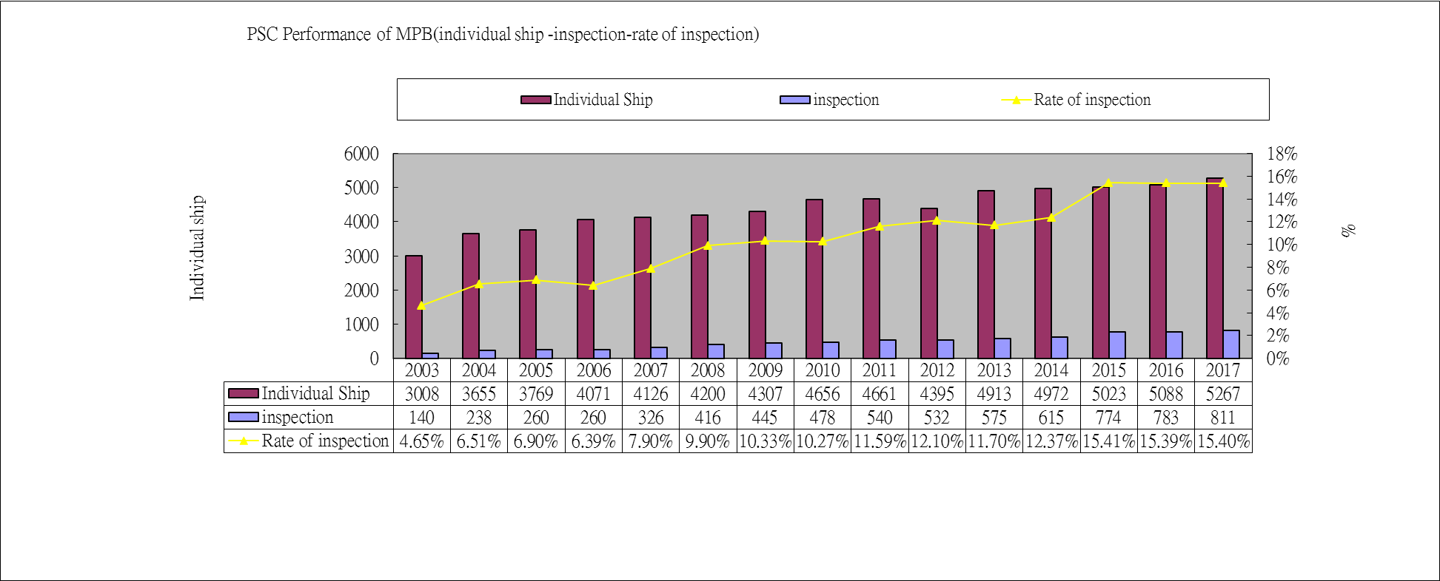

Fig 4 PSC inspection amount and rate
  - PSC inspection deficiency amount and rate
The numbers of deficiency ship suffered from 104 ships increase to 557 ships as well as the rate of deficiency ship suffered from 74.2% decrease to 68.6% since 2003 to 2017 as Fig 5.
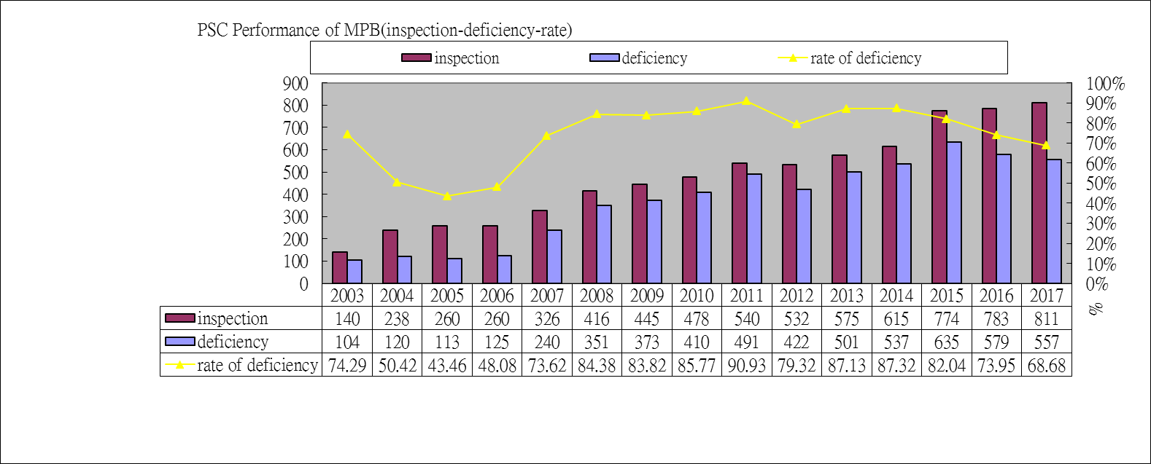

Fig 5 PSC inspection deficiency amount and rate
  - PSC inspection detention amount and rate
The numbers of detention ship suffered from 9 ships increase to 119 ships as well as the rate of detention ship suffered from 6.4% raise to 14.6% since 2003 to 2017 as Fig 6
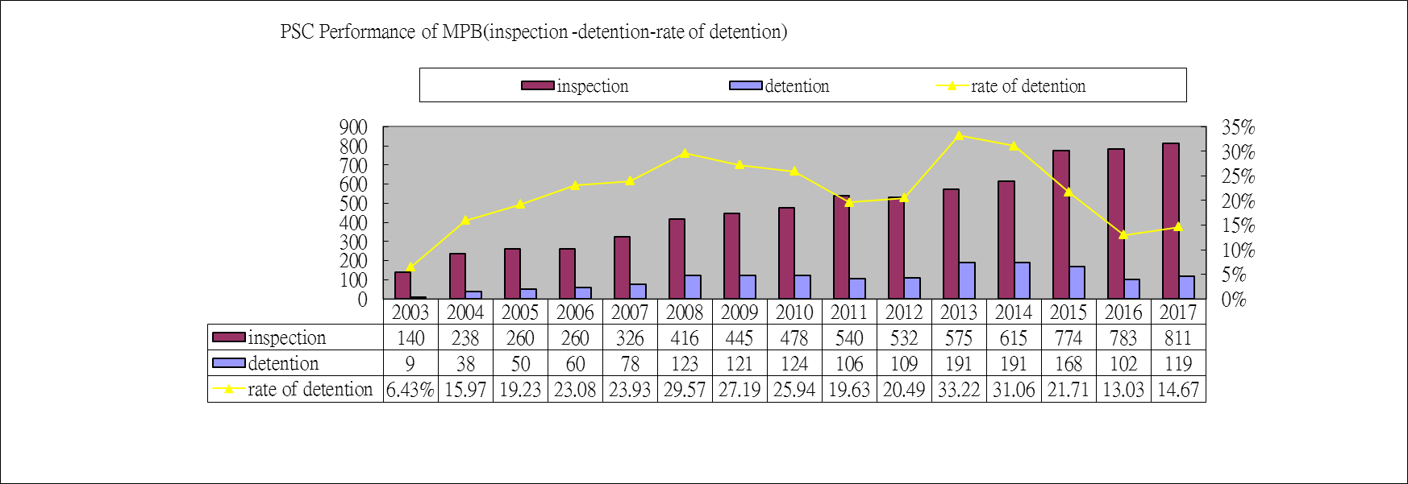

Fig 6 PSC inspection detention amount and rate.

Inspect highlight in 2017
- Cooperation with Tokyo Mou & Paris Mou implement PSC concentrated inspection campaign(CIC) that item of Safety of Navigation, including ECDIS.
- Enhanced inspection frequency of foreign oil tanker: According to the announcement of Ministry of Transportation and Communications (MOTC) on 19th September 2012 that【Adopt regulation 20(5) and 20(7), and regulation 21(5) and 21(6) of MARPOL 73/78 AnnexⅠ”Regulations for the Prevention of Pollution by oil”. ”Foreign single hall oil tankers of 5,000 tons deadweight and above” and“Foreign single hall oil tankers carrying heavy grade oil as cargo of 600 tons deadweight and above ” are denied entry into the ports and offshore terminals under the jurisdiction of Republic of China from 1 January 2013】
- Strengthen the inspection of general cargo ships and bulk carriers, especially the inspection of foreign vessels in which carried gravel in general cargo ships.
- After discuss with delegates of MAC make a target of inspection amount of 779 ship as rate of 15 percentage base on individual entry ship number in 2016.As well as after numerous scrolling reviews during September to the end of Year for revise the inspection goal of rate of 15% base on 2017 amount of individual ships .
The statistics provide from MTNet. There are finally 811 ships were inspected as ratio of 104.1% base on 779 ship(target of inspect amount), and 15.4% base on individual entry ship number in 2017.

2017 PSC Performance
- Foreign ship （Individual Ship）access to the port of Taiwan ROC were amount of 5,267 ships base on the 2017 statistics of MTNet, There are 811 ships were inspected which rate of inspect 15.4%.
- According inspect vessel type analysis that bulk carrier and general cargo ship were most frequency inspected then Tanker and container . Major categories of deficiencies were Safety of Navigation、Working and Living Conditions 、Fire safety、Certificate & Documentation verify、Lifesaving appliances、Pollution prevention、Watertight、Weather tight conditions etc...
- The statistics of the mainland China vessels were inspected on both sides of the Straits are as follows：Access enter the port of Taiwan in 2017 were total amount 342 ships ,were inspected 145 ships which rate of inspection 42.4%..
- Additional inspection Safety of Navigation, including ECDIS during September to November for consistence with Concentrated Inspection Campaign (CIC) of Tokyo Mou.
- Inspection performance in 2017: Under the purpose of rate of inspection 15 % which ship enter to the port of Taiwan R.O.C. The target of ship inspection were 779 ships, There are 811 ships were inspected which rate of inspection 104.1%;Total amount of individual ship enter to port of Taiwan were 5,267 in 2017 which rate of inspection 15.4%.

PSC 4 Quarter implementation in 2017
 | 1Q | 2Q | 3Q | 4Q | Total
Inspect target | 196 | 195 | 194 | 194 | 779
Implementation | 207 | 213 | 206 | 185 | 811
Rate | 105.6% | 109.2% | 106.2% | 95.4% | 104.1%

Table 2: Statistics data by season

Fig. 7 statistics data by season
- Deficiencies types for Port State Control inspection in 2017:
Analysis Major categories of deficiencies were Safety of Working and Living Conditions 、Safety of Navigation、Certificate & Documentation verify、Fire safety、Lifesaving appliances… etc.

Table.3 Major categories of deficiencies 2017
- Statistic List of ship types for Port State Control inspection in 2017
A total of 811ship types were inspected by port state control in 2016. There were338 bulk carriers, 235 general cargo ships, 93 oil tankers, 56 container ships.PSCO inspection focus on the high risk ship of bulk carrier、general cargo and oil tanker as Table 3
TYPE | Inspection
BULK CARRIER | 338
GENERAL CARGO SHIP | 235
OIL TANKER | 93
FULL CONTAINER SHIP | 56
OIL & CHEMICALS TANKER | 14
CHIP CARRIER | 11
PASSENGER SHIP | 11
MULTI-PURPOSE SHIP | 10
CEMENT CARRIER | 8
OTHER | 35
TOTAL | 811

Table 4:PSC inspection amount by ship type

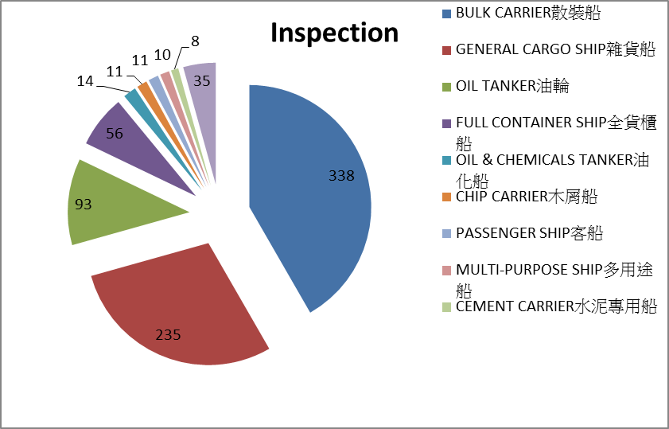

Fig.8:PSC inspection amount by ship type

- Inspection efforts of Flag state ship in 2017
Under statistical analysis Port State control inspection focus on the Flag of Convenience ship. To sequence in order ,were Panama 243, Hong Kong 152, mainland China 61, Singapore54, Marshall Islands 45, Liberia 38, Republic of Korea 24, Republic of Palau 24,Sierra Leone 24, Belize 17 Vietnam 16 ,...etc.

Table 5:PSC inspection amount by flag state

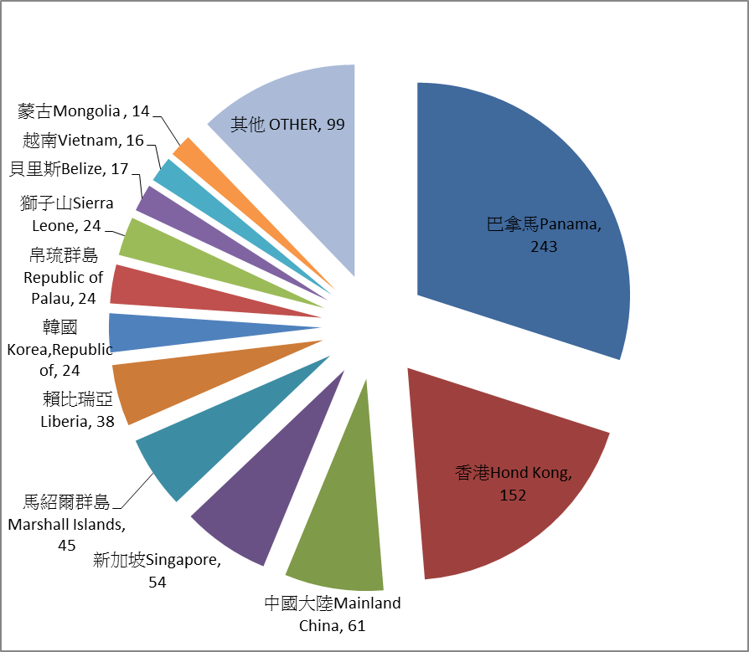

Fig.9:PSC inspection amount by flag state
- Implementation of Port State Control in 2017
General categories on port state control inspection by age of vessel as Table 6
2017 | Age | Individual Ship (A) | inspection(B) | deficiency (C) | detention (D) | Rate of inspection (B/A) | Rate of deficiency (C/B) | Rate of detention (D/B)
MPB | <10y | 3016 | 327 | 184 | 15 | 10.84% | 56.27% | 4.59%
MPB | 11y~15y | 1120 | 169 | 121 | 15 | 15.09% | 71.60% | 8.88%
MPB | 16y~20y | 604 | 140 | 106 | 18 | 23.18% | 75.71% | 12.86%
MPB | >21y | 527 | 175 | 146 | 71 | 33.21% | 83.43% | 40.57%
MPB | Total | 5267 | 811 | 557 | 119 | 15.40% | 68.68% | 14.67%

Table 6:General categories on port state control inspection by age of vessel

Fig.10:PSC inspection, deficiency and detention amount

Fig.11:PSC inspection, deficiency and detention rate

- Implementation of Port State Control on Maritime affairs centers in 2017
- Sum of inspection on Maritime affairs centers
2017 | MAC | Individual Ship (A) | inspection(B) | deficiency (C) | detention (D) | Rate of inspection (B/A) | Rate of deficiency (C/B) | Rate of detention (D/B)
MPB | North MAC | 1,281 | 186 | 119 | 19 | 14.52% | 63.98% | 10.22%
MPB | Central MAC | 1,705 | 216 | 173 | 42 | 12.67% | 80.09% | 19.44%
MPB | South MAC | 3,571 | 345 | 244 | 57 | 9.66% | 70.72% | 16.52%
MPB | East MAC | 192 | 64 | 21 | 1 | 33.33% | 32.81% | 1.56%
MPB | MPB | 5,267 | 811 | 557 | 119 | 15.40% | 68.68% | 14.67%

Table 7:Sum of inspection on Maritime affairs centers
- PSC inspection, deficiency and detention statistics on Maritime affairs centers

Fig.12: deficiency and detention statistics on Maritime affairs centers

- PSC inspection, deficiency and detention rate on Maritime affairs centers

Fig.13: deficiency and detention rate on Maritime affairs centers

Inspection highlight in 2018
- In order to update the PSCO inspection knowledge and skill to the same level as that of the major Port State Control MOUs. Propose a training plan of Regulations for the Prevention of Air Pollution from Ships cooperation with Taiwan-Canada Maritime Systems Technology Program by COMART International Corp for Tokyo MOU CIC 2018.
- Port State Control Inspection the so-called high-risk ship was definition by MOTC in 2010 as follow:
- Age of the ship more than 15 years as well as more than 3,000 gross tonnage of oil tankers
- Age of the ship for more than 10 years of chemical tankers and liquefied gas tankers.
- Bulk carriers of more than 12 years of age.
- Passenger ships of more than 15 years of age.
- Inspection focus on Single hull oil tankers and chemical tankers：
- Enhanced inspection frequency of foreign oil tanker: According to the announcement of Ministry of Transportation and Communications (MOTC) on 19th September 2012 that【Adopt regulation 20(5) and 20(7), and regulation 21(5) and 21(6) of MARPOL 73/78 AnnexⅠ“Regulations for the Prevention of Pollution by oil”.“Foreign single hall oil tankers of 5,000 tons deadweight and above”and“Foreign single hall oil tankers carrying heavy grade oil as cargo of 600 tons deadweight and above ” are denied entry into the ports and offshore terminals under the jurisdiction of Republic of China from 1 January 2013】.
- Inspection some Tankers and chemical vessels according with Annex II of MARPOL and International Code for the Construction and Equipment of Ships Carrying Dangerous Chemicals in Bulk(IBC Code).
- Port state control officers come on board inspection according with international convention of BUNKERS and CLC focus on the Insurance certificate that assure by the ship´s owner.
- The International Convention for the Control and Management of Ships' Ballast Water and Sediments (BWM Convention) was enter into force on 8 September 2017 owing to the convention stipulates that it will enter into force 12 months after ratified by a minimum of 30 States, representing 35% of world merchant shipping tonnage. The accession brings the combined tonnage of contracting States in the end of Sep 2017 to the treaty be 74.9%, with 67 contracting Parties.
The Ballast Water Management Convention will require all ships under international trade to manage their ballast water and sediments to certain standards, according to a ship-specific ballast water management plan. Port State Control Officers should be inspected all ships with a ballast water record book and an International Ballast Water Management Certificate.
- Because of foreign sub-standard ships which oil tanker and bulk carrier access enter the port of Taiwan as well as sail Surrounding waters make a lot of issue of concern which marine ecological environment and safety navigation. MPB conducted a Project to inspect by PSCO focus on sub-standard ships (Including focus list of 62 ships oil tanker and 17 ships bulk carrier).
- Enhanced inspection of ship type of bulk carrier and general cargo ship which age more than 16 years old, and which the purpose of Gravel loading.

Target of inspection distribute to maritime affairs centers as quarters of year.
The MPB was founded on March 1, 2012, Port state control sustain inspection of foreign vessels in national ports to verify that the condition of ships and equipment comply with the requirements of international conventions and that ships are manned and operated in compliance with applicable international laws.
For the purpose describe above, Target of inspection in 2018 compare with 2017 were raised 26 ships from 779 ships to 805 ships, Distribution as follow:
- North Maritime affairs center 182 ships
- Central Maritime affairs center 215 ships
- South Maritime affairs center 344 ships
- East Maritime affairs center 64 ships.
In order to reaching the goal of rate of 15% inspection, PSCO will recheck frequently for update performance.

 | Q1 | Q2 | Q3 | Q4 | Total | Rate of inspection
Inspected in 2017 | 207 | 213 | 206 | 185 | 811 | 15.40%
Target for inspection in 2017 | 196 | 195 | 194 | 194 | 779 | 15.00%
Target for inspection in 2018 | 202 | 202 | 201 | 200 | 805 | 15.00%

Table 8:PSC inspection amount in 2017 and 2018

 | NAC | CAC | SAC | EAC | Total
Inspected in 2017 | 186 | 216 | 345 | 64 | 811
Target for inspection in 2017 | 176 | 208 | 333 | 62 | 779
Target for inspection in 2018 | 182 | 215 | 344 | 64 | 805

Table 9:PSC inspection amount between 2017 and 2018 by maritime affairs center

Fig 14:Number of target & Inspected by Season during 2017-2018

Fig 15:Number of target &Inspected during by Maritime affairs centers 2017-2018

PSCO training and recruit project in 2018
PSCO could not be dedicated to the job of PSC inspection due to personal promotion or retirement .MPB had been Conducted the basic training of Port State Control Inspector for new recruiter according to the IMO Model Course3.09 during 30th May to 17th June 2016.
- The issues for PSCO professional training
For the purpose of enhance ability and quality of PSCO, There are two project be conducted which Professional training for Senior and junior.

- Specifically training：
      - For the issue of Air Pollution from Ships in Tokyo MOU CIC will be held during September to November 2018, Conducting the Professional courses by surveyor or professor who are familiar with the MARPOL Annex VI Regulations for the Prevention of Air Pollution from Ships.
      - Owing to the cruise ship enter the ports of Taiwan frequently, Focus to the issue of emission of Sewage from Ships, Conducting the Professional courses by surveyor or professor who are familiar with the Annex IV of MARPOL Regulations for the Prevention of Pollution by Sewage from Ships.
      - Dangerous goods in Packaged Form inspection: Conduct the Professional courses of Annex III of MARPOL 73/78 and Carriage of dangerous goods of SOLAS Chapter VII as well as IMDG Code.

- The normal training：
      - Arrangement the courses implement for PSCO inspection on board through proficient in the international convention teaching by Senior Captain、Engineer、Surveyor and maritime lawyer and :
      - Participating international convention courses in the seminar held by the relevant recognize organization.
      - Connecting the Resolution A.1119(30) of IMO that Procedures for port state control，Also including international conventions as fallow:
- International Convention for the Safety of Life at Sea (SOLAS), 1974 as amended.
- International Convention on Load Lines, 1966, as Amended by the Protocol of 1988.
- International Convention for the Prevention of Pollution from Ships, 1973 as modified by the Protocol of 1978.
- The International Convention on Standards of Training, Certification and Watch-keeping for Seafarers STCW 78.
- International Convention on Tonnage Measurement of Ships, 1969.Tonnage 69.
- C147 - Merchant Shipping (Minimum Standards) Convention, 1976 (No. 147).
- International Convention on the Control of Harmful Anti-fouling Systems on Ships, 2001.
- International Regulations for Preventing Collisions at Sea, 1972,COLREG 72.
- Resolution A.1119(30) Adopted on 6 December 2017,the Procedures for Port State Control.
- Tokyo Memorandum.
- International Safety Management Code( ISM CODE).
- Maritime Labour Convention, 2006,(MLC 2006).
- CANADA-TAIWAN MOU ON MARITIME SYSTEMS TECHNOLOGY PROGRAM：
Provide expert training for Port State Control officers by Canada experts in order to update the PSCO inspection knowledge and practices to the same level as that of the major Port State Control MOUs.In the other hand the class room training course will focus on ship inspection training program for new trainees with reference to Port State Control standards.
- Risk vessels select system set up in MTNet consistent with Tokyo MOU：
Risk vessels select system set up in MTNet refer to New inspection regime (NIR) of Tokyo MOU .The targeting of ships is based on a “Ship Risk Profile” (SRP). The SRP Calculator can be used to evaluate if a ship will be considered as High Risk Ship (HRS), Standard Risk Ship (SRS) or Low Risk Ships (LRS).
The Ship Risk Profile (SRP) is based on the following factors, using details of ship’s inspections in the last 36 months:
- Type and age of ship
- Number of deficiencies
- Number of detentions
- Performance of ship’s flag :
BGW list: Black-Gray-White list of flag status based on a 36 months inspection data .
- Performance of the Recognised Organisation (RO): RO performance status (High,Medium,Low,Very Low) based on 36 months inspection data.
- Performance of the Company responsible for the ISM Management (holder of Document of Compliance):
Status as High, Medium,Low and Very Low, based on 36 months inspection data.

Low Risk Ship (LRS) | 9-18 months
Standard Risk Ship (SRS) | 5-8 months
High Risk Ship (HRS) | 2-4 months

Table 10: Time window of PSC inspection.
Priority I: ships must be inspected because the time window has closed.
Priority II: ships may be inspected because they are within the time window of inspection.
- Training for High risk ships of Oil tankers and Chemical ship:
Conduct the Professional courses of AnnexⅠ、Ⅱof MARPOL 73/78 and International code for the construction and equipment of ships carrying dangerous chemicals in bulk,( IBC code) in comply with the announcement of Ministry of Transportation and Communications (MOTC) on 19th September 2012 that【Adopt regulation 20(5) and 20(7), and regulation 21(5) and 21(6) of MARPOL 73/78 AnnexⅠ”Regulations for the Prevention of Pollution by oil”. ”Foreign single hall oil tankers of 5,000 tons deadweight and above” and“Foreign single hall oil tankers carrying heavy grade oil as cargo of 600 tons deadweight and above ” are denied entry into the ports and offshore terminals under the jurisdiction of Republic of China from 1 January 2013】.
- Human Resource of PSC：
- After recruit from National Civil Service Senior Examination in 2014,There were 30 persons completed the course of IMO Model Course 3.09 so far, that means has been enhanced the human Resource of PCS in MPB.
- Current persons service on PSC：
- One qualify person in headquarter of MPB
- There are 10 qualify persons service on North maritime affairs center .
- There are 4 qualify persons service on Central maritime affairs center.
- There are 10 qualify persons service on South maritime affairs center .
- There are 4 qualify persons service on South maritime affairs center .

Conclusion
- A Port State Control Officer (PSCO) carries out port State control inspection on board. The PSCO is a properly qualified person, authorized to carry out port State control inspections in accordance with the Commercial port law in Taiwan ROC, by the Maritime Authority of the port State and acts under its responsibility. All PSCO’ s carry an identity card, issued by maritime and port bureau MOTC.
PSCO should ensure effective and harmonized inspection procedures, which are followed throughout the international regulation to maintain ship and life in safety、preventing environment pollution as well as kept port facilities and ship in security.
Both side of Taiwan and Mainland china has been directly sail between Taiwan Strait for many years. Intent to be able to sustainable the system which communication each other for the purpose of port state control by model of MOU.
- PSCO in Taiwan ROC, that conduct the port state control has been more than 10 years for the purpose of vessels safety、clean ocean as well as security of port facility and ships through serious inspection by PSCO, In the other hand make training for improving the ability and quality of PSCO are necessary.
- In order to consistent with International Convention for the Control and Management of Ships' Ballast Water and Sediments (BWM) be forced on September 2017,PSCO attend to inspection the ship which enter the port of Taiwan, as well as encourage and guide the ship owner and captain be able to implement the Self-management .

Appendix:

Appendix 1-Flow chart of PSC operation

Appendix 2-Form-A1

Appendix 3-Form-B1

Appendix 4- (Notificatio of release of ship)

Appendix 5- (Notification of detention of ship)

Appendix 6-Report of deficiency

Appendix 7(Report of action taken to the notifying authority)

Appendix 8-e-mail and address information for Flag states of ship
RO | RO | E Mail | Address | Phone No.
ABS  (America Bureau of Shipping) | 美國驗船協會  臺北辦事處 | abstaipei@eagle.org | ¹⁰⁴⁵⁸臺北市松江路148號4樓 | (02)  25230535
DNV GL Business Assurance Co., Ltd | 立恩威國際驗證股份有限公司 | Service.Taiwan@dnvgl.com<Service.Taiwan@dnvgl.com>; | ²²⁰⁴⁶新北市板橋區文化路二段293號29樓 | (02)  82537800
DNV GL Business Assurance Co., Ltd | 立恩威國際驗證股份有限公司 | Service.Taiwan@dnvgl.com<Service.Taiwan@dnvgl.com>; | ⁸⁰⁶高雄市復興四路1號5樓 | (07)  3387572
BV  (Bureau Veritas-Registre) | 法商法立德公證有限公司 | Jennifer.chen@tw.bureauveritas.com | ¹⁰⁵臺北市松山區南京東路4段16號3 | (02)  25707657
NK  (Nippon Kaiji  Kyokai) | 日本海事協會 | tp@classnk.or.jp  maxihsu@classnk.or.jp | ¹⁰⁵臺北市松江路87號7樓G室 | (02)  25081692  25047006
CCS  (China Classification  Society) | 中國船級社 | ccs@ccs.org.cn | ¹⁰⁰⁰⁰⁷北京市東直門南大街9號船檢大樓 | 010-58112811
KR  (Korean Register of Shipping) | 韓國驗船協會 | krsiacs@krs.co.kr | 36,Myeongji Ocean City 9-10  Gangseo-gu,618-814 Rep of Korea | 1566-1682,  82-70-8799-7114
LR  (Lioyd’s Register) | 英國勞氏驗船協會 | Lloydsreg@lr.org | 71 Fenchurch Street,London,  EC3M 4BS,UK
RO | RO | E Mail | Address | Phone No.
PRS(Poland Register of  Shipping) | 波蘭驗船協會 | mailbox@prs.pl  iacs@prs.pl | Polski Rejestr Statkow S.A. al.  Generala Jozefa Hallera 126 80-416 Gdansk Poland | 58 346 17 00  58 751 11 00
RINA | 義大利驗船協會 | anconaced@rina.org  info@rina.org | Via.Sandro Totti,3-20 piano | +39 071 4192241  +39 071 4192299
RS(Russian Register of  Shipping) | 俄羅斯驗船協會 | pobox@rs-class.org  international.dept@rsclass.org | 8,Dvortsovata Naberezhnaya,  Saint-Petersburg,Russian Federation | +7812 3802072
IR(Indian Register of  Shipping) | 印度驗船協會 | irqs@irclass.org | 52A,Adi Shankaracharya Marg.Opp.Powal Lake,Powai,Mumbai 400 072-India | +91 22 3051 9800
PSR(Panama Shipping Register) | 巴拿馬驗船協會 | didelpsr@panamashipping.com  didelpsr@gmail.com | Wa Espana,La Cresta,Calle Gabriela Mistral Casa No.10  Panama,Rep. De Panama | (507)263-6601  (057)263-6578
IBS(Isthmus Bureau of Shipping) | 巴拿馬IBS驗船協會 | ibs@ibs.com.pa | Williamson Place Bldg No.0764-F,La Boca,Balboa,Panama,Rep. of Panama | (507)211-2122

Appendix 9-Representative office in Taiwan
Asia-Pacific

館名(中文) | 館名EMBASSY ( English) | 姓名Name  (English) | 地址(中文) | 電話(Tel) | 傳真(FAX) | 電子郵件(e mail )
澳洲辦事處 | AUSTRALIAN OFFICE | REPRESENTATIVE Mr. GARY RICHARD COWAN | 11073 臺北市松高路9-11號27-28樓 | 8725-4100 | 8789-9599
汶萊貿易旅遊代表處 | BRUNEI DARUSSALAM TRADE AND TOURISM OFFICE | REPRESENTATIVE MRS. NORHAYATI ISMAIL | 10491 臺北市建國北路1段80號6樓 | 2506-3767 | 2506-3721
印度—台北協會 | INDIA-TAIPEI ASSOCIATION | DIRECTOR GENERAL MR. SRIDHARAN MADHUSUDHANAN | 11012 臺北市基隆路1段333號20樓2010室 | 2757-6112 | 2757-6117 | secy@india.org.tw
駐台北印尼經濟貿易代表處 | INDONESIAN ECONOMIC AND TRADE OFFICE TO TAIPEI | REPRESENTATIVE Mr. Robert James Bintaryo | 11492 臺北市瑞光路550號6樓 (倫飛大樓) | 8752-6170 | 8752-3706 | ieto@ms8.hinet.net
日本台灣交流協會—台北事務所 | JAPAN-TAIWAN EXCHANGE ASSOCIATION, TAIPEI OFFICE | CHIEF REPRESENTATIVE MR. MIKIO NUMATA | 10547 臺北市慶城街28號 (通泰商業大樓) | 2713-8000 | 2713-8787 | ryoji-k1@tp.koryu.or.jp
日本台灣交流協會—高雄事務所 | JAPAN-TAIWAN EXCHANGE ASSOCIATION, KAOHSIUNG OFFICE | DIRECTOR GENERAL MR. KINZO NAKAGUN | 80272 高雄市苓雅區和平一路87號9樓 | (07) 771-4008 | (07) 771-2734
吉里巴斯共和國大使館 | EMBASSY OF KIRIBATI | H.E. AMBASSADOR TEEKOA IUTA | 11157臺北市天母西路62巷9-1號10樓 | 02-2876-9042 | 02-2876-4983 | eataipei@mfa.gov.ki
馬來西亞友誼及貿易中心 | MALAYSIAN FRIENDSHIP AND TRADE CENTRE, TAIPEI | PRESIDENT DATUK PUNG SHUK KEN ADELINE | 10595 臺北市敦化北路102號8樓 (三和塑膠大樓 ) | 2713-2626 | 2514-9864 | mwtaipei@kln.gov.my
馬紹爾群島共和國大使館 | EMBASSY OF THE REPUBLIC OF THE MARSHALL ISLANDS | H.E. AMBASSADOR FREDERICK MULLER | 11157 臺北市天母西路62巷9-1號4樓 | 2873-4884 | 2873-4904 | rmiemb.tpe@msa.hinet.net
緬甸聯邦共和國駐台北貿易辦事處 | MYANMAR TRADE OFFICE (TAIPEI), THE REPUBLIC OF THE UNION OF MYANMAR | TRADE REPRESENTATIVE MR. MYO THET | 11568 臺北市南港區經貿二路188號6樓 | 2789-2100#101 | 2789-1670 | mto.taipei.tw@gmail.com
諾魯共和國大使館 | EMBASSY OF THE REPUBLIC OF NAURU | H.E. AMBASSADOR Chitra Jeremiah | 11157 臺北市天母西路62巷9-1號11樓 | 2876-1950 | 2876-1930 | embassy@nauru.org.tw
紐西蘭商工辦事處 | NEW ZEALAND COMMERCE AND INDUSTRY OFFICE | DIRECTOR MS. MOIRA MCDONALD TURLEY | 11047臺北市松智路1號9樓 | 2720-5228 | 2720-5255 | nzcio.tpe@msa.hinet.net
帛琉共和國大使館 | EMBASSY OF THE REPUBLIC OF PALAU | H.E. AMBASSADOR DILMEI LOUISA OLKERIIL | 11157 臺北市天母西路62巷9號5樓 | 2876-5415 | 2876-0436 | palau.embassy@msa.hinet.net
巴布亞紐幾內亞駐臺商務代表處 | PAPUA NEW GUINEA TRADE OFFICE IN TAIWAN | REPRESENTATIVE MR. TOMMY KAMBU KUNJI | 11010臺北市信義區松仁路3號4樓412室 | (02)8789-7055 | (02)8789-7058
馬尼拉經濟文化辦事處 | MANILA ECONOMIC AND CULTURAL OFFICE | RESIDENT REPRESENTATIVE MR. ANGELITO T. BANAYO | 10493臺北市內湖區洲子街55&57號2樓 | 02-2658-8825 | 02-2658-8867 | meco.tpe@msa.hinet.net
馬尼拉經濟文化辦事處—高雄分處 | MANILA ECONOMIC AND CULTURAL OFFICE, KAOHSIUNG EXTENSION OFFICE | DIRECTOR, KAOHSIUNG OFFICE MR. MARIO I. MOLINA | 80761 高雄市三民區民族一路80號9樓之2 | (07) 398-5935～6 | (07) 398-5929
馬尼拉經濟文化辦事處—台中分處 | MANILA ECONOMIC AND CULTURAL OFFICE, TAICHUNG EXTENSION OFFICE | DIRECTOR, TAICHUNG OFFICE MR. SERGIO TAN EULOGIO | 40341 臺中市西區民權路239號4樓2A室 | (04) 2302-9080 | (04) 2302-9082
駐臺北韓國代表部 | KOREAN MISSION IN TAIPEI | REPRESENTATIVE MR. YANG CHANG-SOO | 11012 臺北市基隆路1段333號15樓1506室 | 2758-8320～25 | 2757-7006 | taipei@mofa.go.kr
新加坡駐台北商務辦事處 | SINGAPORE TRADE OFFICE IN TAIPEI | TRADE REPRESENTATIVE MR. WONG WIE KUEN | 10688 臺北市仁愛路4段85號9樓 | 2772-1940 | 2711-7383 | singtr_tpe@mfa.sg
索羅門群島大使館 | EMBASSY OF SOLOMON ISLANDS | H.E. AMBASSADOR JOSEPH WALEANISIA | 11157 臺北市天母西路62巷9號7樓 | 2873-1168 | 2873-5224 | embassy@solomons.org.tw
泰國貿易經濟辦事處 | THAILAND TRADE AND ECONOMIC OFFICE | Thongchai CHASAWATH | 10459 臺北市松江路168號12樓 | 2581-1979 | 2581-8707 | info@tteo.tw
吐瓦魯國大使館 | EMBASSY OF TUVALU | H.E. AMBASSADOR LIMASENE TEATU | 11157臺北市天母西路62巷9-1號9樓 | 02-28767606 | 02-28767603 | tuvaluembassyroc@gmail.com
駐台北越南經濟文化辦事處 | VIETNAM ECONOMIC AND CULTURAL OFFICE IN TAIPEI | REPRESENTATIVE MR. TRAN DUY HAI | 10455 臺北市松江路65號3樓 | 2516-6626 | 2516-6625

West of Asia

館名(中文) | 館名EMBASSY ( English) | 姓名Name  (English) | 地址(中文) | 電話(Tel) | 傳真(FAX) | 電子郵件(e mail )
駐台北以色列經濟文化辦事處 | ISRAEL ECONOMIC AND CULTURAL OFFICE IN TAIPEI | REPRESENTATIVE MR. ASHER YARDEN | 11012 臺北市基隆路1段333號24樓2408室 | 2757-9692 | 2757-7247 | represent-sec@taipei.org.il
約旦商務辦事處 | THE JORDANIAN COMMERCIAL OFFICE | DIRECTOR MR. QUSSAI ABDULL-HAMEED YAKOUB BANI-MUSTAFA | 11148 臺北市忠誠路2段110號1樓 | 2871-7712 | 2872-1176 | jcotpe@ms13.hinet.net
駐台北烏蘭巴托貿易經濟代表處 | ULAANBAATAR TRADE AND ECONOMIC REPRESENTATIVE OFFICE IN TAIPEI | REPRESENTATIVE MR. KHALIUN PANIDJUNAI | 11012 臺北市基隆路1段333號11樓1112室 | 2722-9740 | 2722-9745 | ubtrade.taipei@outlook.com
阿曼王國駐華商務辦事處 | COMMERCIAL OFFICE OF THE SULTANATE OF OMAN-TAIWAN | DIRECTOR MR. WALEED ABDUL MOHSIN ABDUL RAHMAN AL SHEZAWI | 11011 臺北市信義路5段5號世貿中心7G-05室 | 2722-0684 | 2722-0645 | oman0684@gmail.com
莫斯科台北經濟文化協調委員會駐台北代表處 | REPRESENTATIVE OFFICE IN TAIPEI FOR THE MOSCOW-TAIPEI COORDINATION COMMISSION ON ECONOMIC AND CULTURAL COOPERATION |  | 11049 臺北市信義路5段2號9樓 | 8780-3011 | 8780-2511 | info@mtc.org.tw
沙烏地阿拉伯商務辦事處 | SAUDI ARABIAN TRADE OFFICE | REPRESENTIVE DR. RAFAT AHMED KHALEEL AL SAYED | 11157 臺北市天母西路62巷9號4樓 | 2876-1444 | 2876-1614
駐台北土耳其貿易辦事處 | TURKISH TRADE OFFICE IN TAIPEI | REPRESENTATIVE MR. MURAT BAKLACI | 11012 臺北市基隆路1段333號19樓1905室 | 2757-6115 | 2757-9432 | tr-office.taipei@mfa.gov.tr
Africa region

館名(中文) | 館名(外文) | 姓名(英文) | 地址(中文) | 電話 | 傳真 | 電子郵件
奈及利亞駐華商務辦事處 | NIGERIA TRADE OFFICE IN TAIWAN, R.O.C. | Acting Trade Commissioner Ibrahim Mohammed | 22043 新北市板橋區雙十路2段48號12樓 | 02-22501118 | 02-22501117 | nigtroff@ms65.hinet.net
南非聯絡辦事處 | LIAISON OFFICE OF THE REPUBLIC OF SOUTH AFRICA | REPRESENTATIVE MR. ROBERT SERAKI MATSEBE | 10595 台北市敦化北路205號13樓1301室 | 2715-2295 | 2712-5109 | south.africa@msa.hinet.net
史瓦濟蘭王國大使館 | EMBASSY OF THE KINGDOM OF SWAZILAND | H.E. AMBASSADOR THAMIE DLAMINI | 11157 臺北市天母西路62巷9號10樓 | 2872-5934 | 2872-6511 | swazitpi@ms41.hinet.net

Europe

館名(中文) | 館名(外文) | 姓名(英文) | 地址(中文) | 電話 | 傳真 | 電子郵件
奧地利台北辦事處 | AUSTRIAN OFFICE TAIPEI | DIRECTOR MR. ALBIN MAURITZ | 10549 臺北市敦化北路167號10樓 | 8175-3283 | 2514-9980 | taipei-ot@bmeia.gv.at
奧地利商務代表辦事處 | AUSTRIAN COMMERCIAL OFFICE | DIRECTOR MR. CHRISTIAN FUCHSSTEINER | 10595 臺北市敦化北路205號6樓608室 | 2715-5220 | 2717-3242 | taipei@advantageaustria.org
比利時台北辦事處 | BELGIAN OFFICE, TAIPEI | DIRECTOR MR. RIK VAN DROOGENBROECK | 10596 臺北市民生東路3段131號601室 | 2715-1215 | 2712-6258 | taipei@diplobel.fed.be
捷克經濟文化辦事處 | CZECH ECONOMIC AND CULTURAL OFFICE | REPRESENTATIVE MR. VACLAV JILEK | 11071 臺北市基隆路1段200號7樓B室 | 2722-5100 | 2722-1270 | Taipei_Ceco@mzv.cz
丹麥商務辦事處 | THE TRADE COUNCIL OF DENMARK, TAIPEI | DIRECTOR MR. NICHOLAS ENERSEN | 10595 臺北市敦化北路205號12樓1207室 | 2718-2101 | 2718-2141 | tpehkt@um.dk
歐洲經貿辦事處 | EUROPEAN ECONOMIC AND TRADE OFFICE | HEAD OF OFFICE MS. ANNA MARIA MADELEINE MAJORENKO | 11012 臺北市基隆路1段333號16樓1603室 | 2757-7211 | 2757-7209 | admin-taiwan@eeas.europa.eu
芬蘭駐臺灣貿易及創新辦事處 | FINPRO TAIWAN, FINLAND'S TRADE AND INNOVATION OFFICE | REPRESENTATIVE MR. JARI TAPANI SEILONEN | 11071 台北市信義區忠孝東路四段560號13樓 | 886 2 8729 1231 | 886 2 8729 1211 | jari.seilonen@businessfinland.fi
法國在台協會 | FRENCH OFFICE IN TAIPEI | DIRECTOR MR. BENOIT JEAN MARIE VINCENT GUIDEE | 10595 臺北市敦化北路205號10樓1003室 | 3518-5151 | 3518-5189 | presse@france-taipei.org
德國在台協會 | GERMAN INSTITUTE TAIPEI | DIRECTOR GENERAL MR. MARTIN EBERTS | 11049 臺北市信義路5段7號33樓 | 8722-2800 | 8101-6282 | info@taipei.diplo.de
德國經濟辦事處 | GERMAN TRADE OFFICE TAIPEI | EXECUTIVE DIRECTOR MR. AXEL HEINRICH FRITZ LIMBERG | 11012 臺北市基隆路1段333號19樓之9 | 8758-5800 | 8758-5833 | info@taiwan.ahk.de
歌德學院（台北）德國文化中心 | GOETHE-INSTITUT TAIPEI | DIRECTOR MR. JENS ROESLER | 10078 臺北市和平西路1段20號12樓 | 2365-7294 | 2368-7542
教廷大使館 | APOSTOLIC NUNCIATURE | CHARGE D'AFFAIRES A.I. MONSIGNOR SLAĐAN ĆOSIĆ | 10667臺北市和平東路2段265巷7-1號1樓 | 2700-6847 | 2755-1926 | na.taipei@diplomat.va
匈牙利貿易辦事處 | HUNGARIAN TRADE OFFICE | REPRESENTATIVE MR. JANOS FERENC ALBERT | 10462 臺北市敬業一路97號3樓 | 8501-1200~2 | 8501-1161 | mission.tpe@mfa.gov.hu
義大利經濟貿易文化推廣辦事處 | ITALIAN ECONOMIC, TRADE AND CULTURAL PROMOTION OFFICE | REPRESENTATIVE MR. DONATO SCIOSCIOLI | 11012 臺北市基隆路1段333號18樓1808室 | 2345-0320 | 2757-6260 | segreteria.taipei@esteri.it
盧森堡台北辦事處 | LUXEMBOURG TRADE AND INVESTMENT OFFICE, TAIPEI | DIRECTOR MS. Tania BERCHEM | 11012台北市信義區基隆路ㄧ段333號18樓1812室 | (02)2757-6007 | (02)2757-6002 | assistant@luxtrade.org.tw
華沙貿易辦事處 | WARSAW TRADE OFFICE | DIRECTOR GENERAL DR. MACIEJ ARTUR GACA | 11012 臺北市基隆路1段333號16樓1601室 | 7718-3300 | 7718-3309 | taipei.warsaw.office@msz.gov.pl
斯洛伐克經濟文化辦事處 | SLOVAK ECONOMIC AND CULTURAL OFFICE, TAIPEI | REPRESENTATIVE MR. MARTIN PODSTAVEK | 11012 臺北市基隆路1段333號12樓1203室 | 8780-3231 | 2723-5096 | seco.taipei@mzv.sk
西班牙商務辦事處 | SPANISH CHAMBER OF COMMERCE | DIRECTOR GENERAL MR. JOSE LUIS ECHANIZ COBAS | 10478 臺北市民生東路3段49號10樓B1室 | 2518-4905 | 2518-4891 | taipei@comercio.mineco.es
瑞典貿易暨投資委員會台北辦事處 | THE SWEDISH TRADE & INVEST COUNCIL | REPRESENTATIVE MR. HENRIK MIKAEL PERSSON | 11012 臺北市基隆路1段333號24樓2406室 | 2757-6573 | 2757-6723 | taipei@business-sweden.se(Trade section) taipei_consular@business-sweden.se(Consular section)
瑞士商務辦事處 | TRADE OFFICE OF SWISS INDUSTRIES | DIRECTOR MR. ROLF URS FREI | 11012 臺北市基隆路1段333號31樓3101室 | 2720-1001 | 2757-6984 | tai.vertretung@eda.admin.ch
荷蘭貿易暨投資辦事處 | NETHERLANDS TRADE AND INVESTMENT OFFICE | REPRESENTATIVE MR. GUY ALEXANDER WITTICH | 11073 臺北市松高路1號13樓之2 | 8758-7200 | 2720-5005 | ntio@ntio.org.tw
英國在台辦事處 | BRITISH OFFICE | REPRESENTATIVE MS. CATHERINE ELIZABETH NETTLETON | 11073 臺北市松高路9-11號26樓 (統一國際大樓) | 8758-2088 | 8758-2050

North America

館名(中文) | 館名(外文) | 姓名(英文) | 地址(中文) | 電話 | 傳真 | 電子郵件
加拿大駐台北貿易辦事處 | CANADIAN TRADE OFFICE IN TAIPEI | EXECUTIVE DIRECTOR MR. MARIO STE-MARIE | 11047 臺北市松智路1號6樓 | 8723-3000 | 8723-3092
美國在台協會—台北辦事處 | AMERICAN INSTITUTE IN TAIWAN, TAIPEI OFFICE | DIRECTOR MR. KIN W. MOY | 10659 臺北市信義路3段134巷7號 | 2162-2000 | 2162-2251 | media@mail.ait.org.tw；aitirc@mail.ait.org.tw
美國在台協會—高雄分處 | AMERICAN INSTITUTE IN TAIWAN, KAOHSIUNG BRANCH OFFICE | BRANCH CHIEF MR. MATTHEW EUGENE O”CONNOR | 80661 高雄市前鎮區成功二路88號5樓 | (07) 335-5006 | (07) 338-0551

Latin America and the Caribbean

館名(中文) | 館名(外文) | 姓名(英文) | 地址(中文) | 電話 | 傳真 | 電子郵件
阿根廷商務文化辦事處 | ARGENTINA TRADE AND CULTURAL OFFICE | DIRECTOR MR. CARLOS ALBERTO ARGAÑARAZ | 11012 臺北市基隆路1段333號15樓1512室. | 2757-6556 | 2757-6445 | atc0326@ms13.hinet.net
貝里斯大使館 | EMBASSY OF BELIZE | H.E. AMBASSADOR DIANE HAYLOCK | 11157 臺北市天母西路62巷9號11樓 | 2876-0894 | 2876-0896 | embassybzroc@gmail.com
巴西商務辦事處 | COMMERCIAL OFFICE OF BRAZIL TO TAIPEI | DIRECTOR MR. FÁBIO GUIMARÃES FRANCO | 11158 臺北市德行西路45號2樓 | 2835-7388 | 2835-7121
智利商務辦事處 | CHILEAN TRADE OFFICE | DIRECTOR MR. AGUSTIN ALEJANDRO CASES NARDOCCI | 11011 臺北市信義路5段5號7B-06室 | 2723-0329 | 2723-0318 | yhuang@prochile.gob.cl, ychen@prochile.gob.cl
薩爾瓦多共和國大使館 | EMBASSY OF THE REPUBLIC OF EL SALVADOR | H.E. AMBASSADOR MARTA CHANG DE TSIEN | 11157 臺北市天母西路62巷9號2樓 | 2876-3606 | 2876-3514 | embasal.taipei@msa.hinet.net
瓜地馬拉共和國大使館 | EMBASSY OF THE REPUBLIC OF GUATEMALA | H.E. AMBASSADOR OLGA MARIA AGUJA ZUNIGA | 11157 臺北市天母西路62巷9-1號3樓 | 2875-6952 | 2874-0699 | embchina@minex.gob.gt
海地共和國大使館 | EMBASSY OF THE REPUBLIC OF HAITI | H.E. AMBASSADOR RACHEL COUPAUD | 11157 臺北市天母西路62巷9-1號8樓 | 2876-6718 | 2876-6719 | haiti@ms26.hinet.net
宏都拉斯共和國大使館 | EMBASSY OF THE REPUBLIC OF HONDURAS | H.E. AMBASSADOR RAFAEL FERNANDO SIERRA QUESADA | 11157 臺北市天母西路62巷9號9樓 | 2875-5507 | 2875-5726 | embajadahondurastw@yahoo.com
墨西哥商務簽證文件暨文化辦事處 | MEXICAN TRADE SERVICES DOCUMENTATION AND CULTURAL OFFICE | MARTIN TORRES GUTIERREZ RUBIO | 11012 臺北市基隆路1段333號15樓1501, 1502, 1514室 | 2757-6566 | 2758-4651 | mexico@mextw.com
墨西哥商務辦事處 | MEXICAN TRADE SERVICES | TRADE COMMISSIONER MR. ARI BEN SAKS GONZALEZ | 11012 臺北市基隆路1段333號29樓2905室 | 2757-6526 | 2757-6180 | mexico@ofmex.tw
尼加拉瓜共和國大使館 | EMBASSY OF THE REPUBLIC OF NICARAGUA | H.E. AMBASSADOR WILLIAM MANUEL TAPIA ALEMAN | 11157 臺北市天母西路62巷9號3樓 | 2874-9034 | 2874-9080
巴拉圭共和國大使館 | EMBASSY OF THE REPUBLIC OF PARAGUAY | H.E. AMBASSADOR MARCIAL BOBADILLA GUILLEN | 11157 臺北市天母西路62巷9-1號7樓 | 2873-6310/11 | 2873-6312 | embapartaiwan@embapartwroc.com.tw
秘魯駐臺北商務辦事處 | COMMERCIAL OFFICE OF PERU IN TAIPEI | DIRECTOR MR. JUAN LUIS KUYENG RUIZ | 11012 臺北市基隆路1段333號16樓1613室 | 2757-7017 | 2757-6480 | postmaster@peru.org.tw
聖克里斯多福及尼維斯大使館 | EMBASSY OF SAINT CHRISTOPHER AND NEVIS | H.E. AMBASSADOR JASMINE ELISE HUGGINS | 11157 臺北市天母西路62巷9-1號5樓 | 2873-3252 | 2873-3246 | embskn.tw@gmail.com
聖露西亞大使館 | EMBASSY OF SAINT LUCIA | Edwin LAURENT | 11012 臺北市基隆路1段333號24樓2407室 | 2757-6900 | 2757-6800 | sluembassy.tw@gmail.com

