施工範圍Working Area
本作業區域為海龍離岸風電場址之海域，場址水深約為36至56公尺，風場區域如圖 1及表格 1所示。施工項目為風機試運轉作業。
The working area is in Hai Long Offshore Wind Farm, the water depth is between 36-56m, the offshore wind farm area is shown in Figure 1 and Table 1. The scope of work is Commissioning of Wind Turbines.
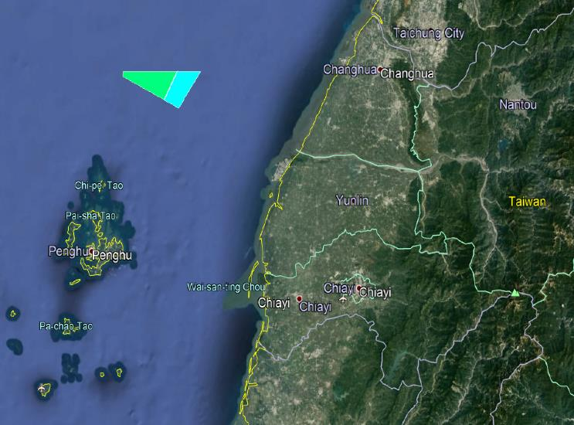
Site 18
Site 19
圖 1 – 海龍二號及三號離岸風場場址 HL2&3 OWF Site
風場 OWF | 東經 E | 北緯 N
HL 2 | 119°48' 49.68"N | 23°58' 8.4"N
HL 2 | 119°51' 26.27"N | 24°2' 38.4"N
HL 2 | 119°55' 40.08"N | 24°2' 40.19"N
HL 2 | 119°51' 18.71"N | 23°57' 1.43"N
HL 3 | 119°40' 53.39"N | 24°2' 33"N
HL 3 | 119°40' 34.67"N | 24°1' 49.44"N
HL 3 | 119°48' 49.68"N | 23°58' 8.4"N
HL 3 | 119°51' 26.27"N | 24°2' 38.4"N
表格 1 – 海龍離岸風場範圍邊界The boundary of Hai Long OWF(WGS84)

- 施工期程 Construction Period
本計畫船舶預計作業期程為115年 03 月 20 日至 115 年 8 月 19日，惟此期程將依照現場施工或海氣象條件而有所變動。
The estimated vessel operation duration is from the 20th of March 2026 to the 19th August 2026, which will vary with practical operation situations and weather conditions.
- 施工廠商與相關聯繫人員
本計畫主要由嘉時航運股份有限公司所承攬，其相關聯繫相關人員如下表所示。
The construction works are carried out by PKR Offshore Co., Ltd, the relevant contacts are shown below.
職稱 | 聯絡人員 | 聯絡資訊
Fleet Manager | Finnick Liu | +886-972-059-292
Operational Executive | James Sung | +886-953-618-566
Port Captain | Mingyu Kim | +82-10-3228-9209
海龍聯絡資訊HL Contact Information
職稱 | 聯絡人員 | 聯絡資訊
Deputy Construction Manager | Toby Strickett | +886-978-348-044
WTG Package Coordinator | Ruth Cheng | +886-978-348-003
WTG Interface Engineer | Jessica Chien | +866 900 841 658

- 工作船舶Vessel
本計畫使用船舶如下所述：
The following vessel will be used:
船舶基本資訊 Vessel Basic Information
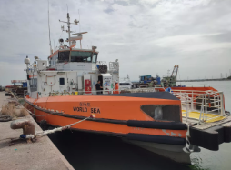
船名Vessel name | World Sea
Call Sign | BR4174
IMO | 9642100
MMSI | 416005863
船舶種類Vessel Type | 人員運輸船 Crew Transfer Vessel
國籍Flag | Republic of China
船長Length | 23.7m
船寬Breadth | 9.5m
吃水深度Draft | 2.1m (Loaded) / 1.4m (Empty)

- 預計航行路線 The Passage Plan
本計畫動員之船舶，將以將軍港作為工作母港，如有緊急情況或氣候影響，一樣使用台中港作為緊急避難港口。
All vessels mobilized in this project will use Taichung Port as their working ports. In case of emergency or weather impact, Taichung Port will also be considered as emergency shelter ports.
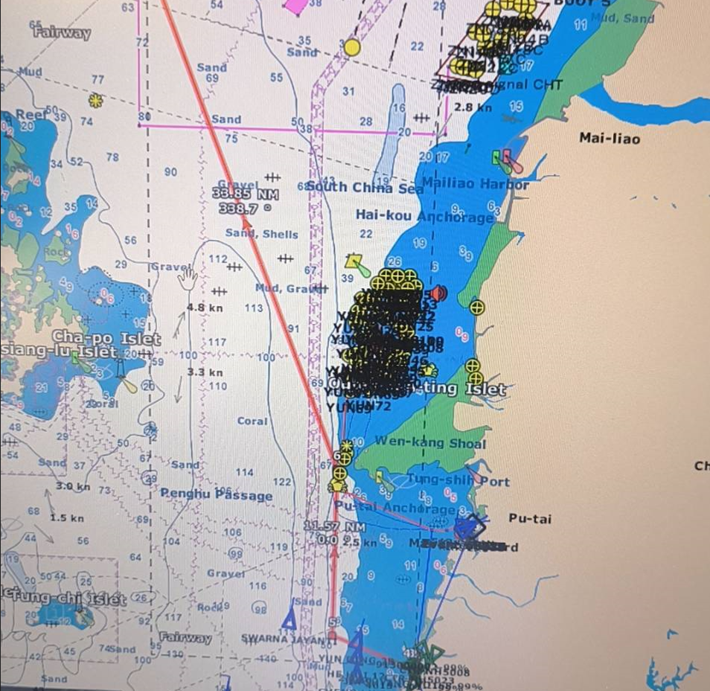

圖 2 – 預計航行路線The Passage Plan
